Introduction to React
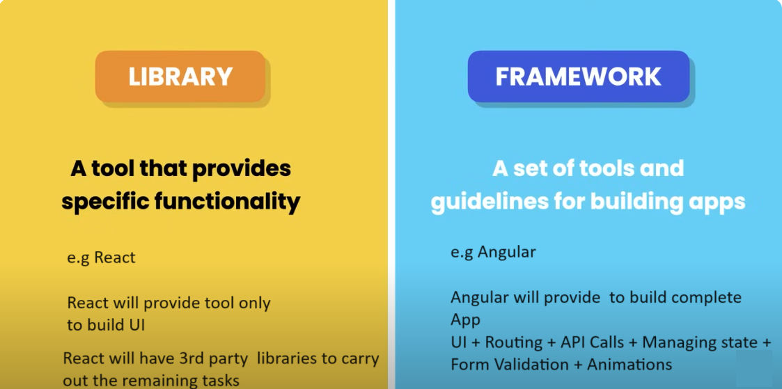
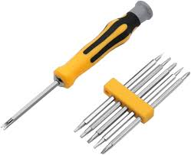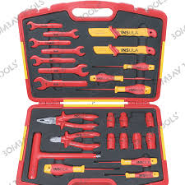

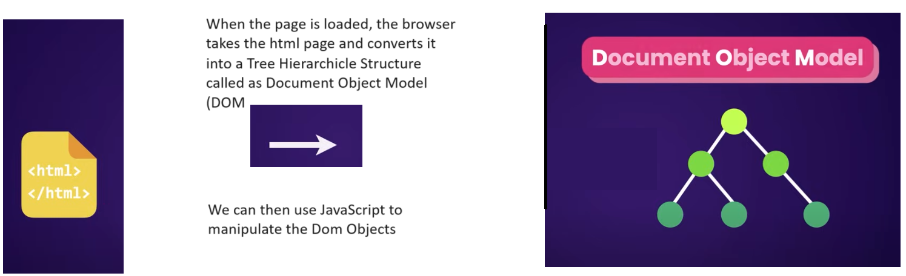

<!DOCTYPE html>
<html>

<head>
<title>My Page</title> <!-- title of page -->
</head>

<body>
<h1 id=”myId”>Hello World</h1>
<p>This is a paragraph.</p>
<ul>
<li>Item 1</li>
<li>Item 2</li>
</ul>
</body>

</html>

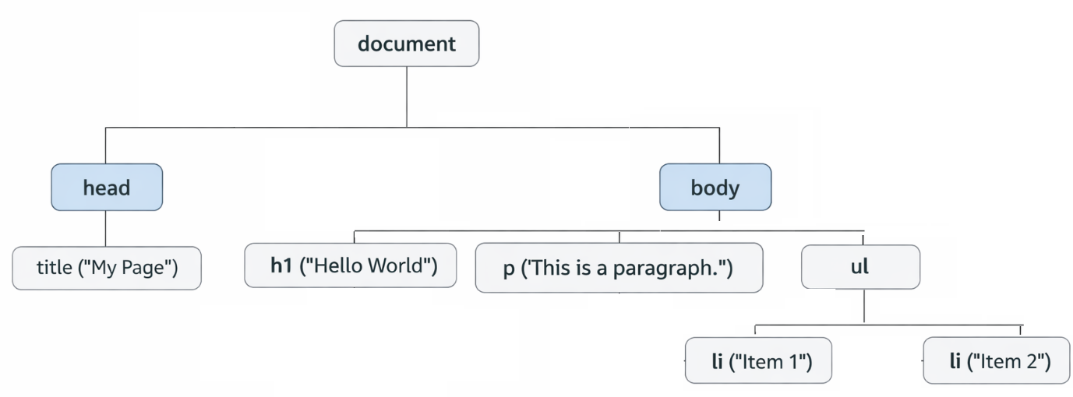

But. As the application grows working with the Dom can become quite challenging & complicated to manage
This is where REACT comes into the picture,
With REACT we don’t have to worry about manipulating the various Dom objects.
In REACT we create a) small b) reusable components.
React will take care of efficiently creating & manipulating the Dom elements

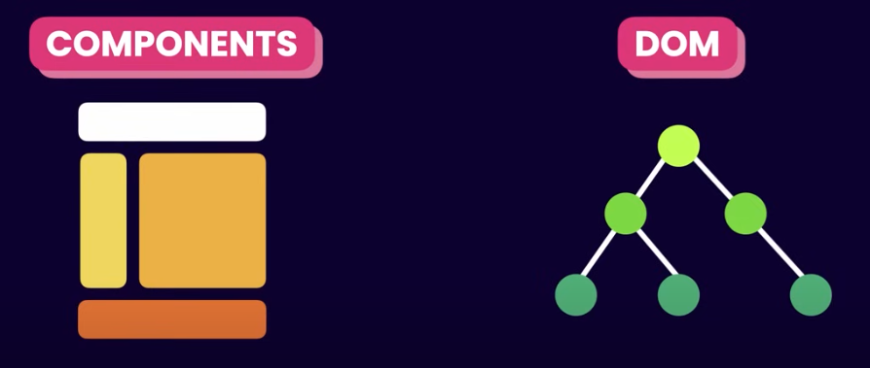
Example :
